Pertemuan 1 : Konvergensi Numerik

Error:

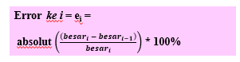

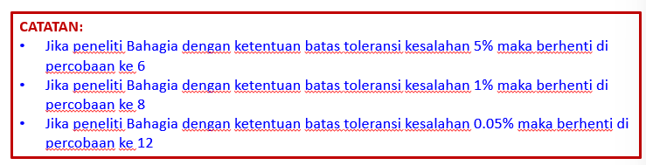

Rumus e^x:

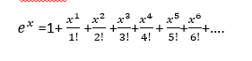

Meet 2 – akar fungsi suatu fungsi non linear

Metoda grafik

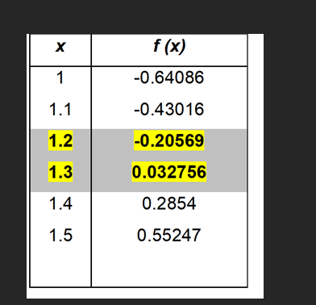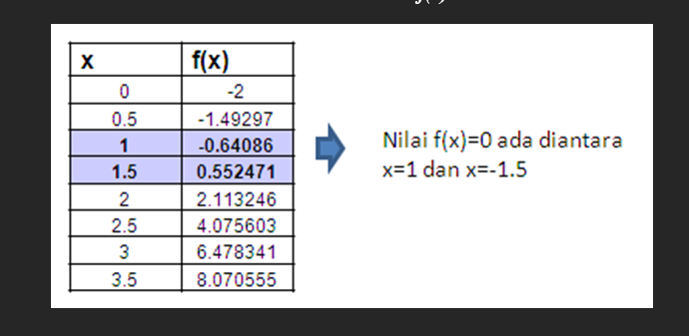

Meet 4 – Biseksi

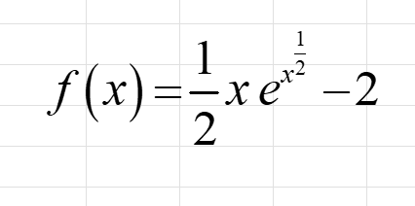

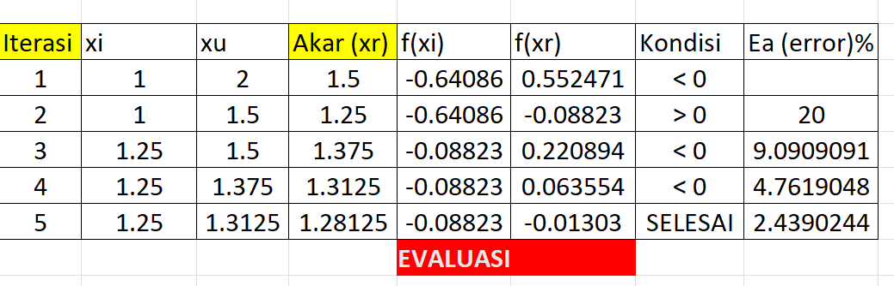

Klo f(xr) nya minus, then it replaces the xu, otherwise replaces the xi. Error counted using the xr.

Meet 4 - akolade

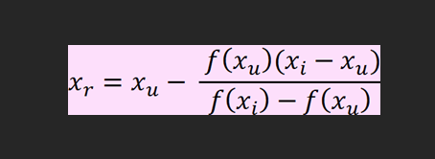

Same principle with bisection but different xr formula

s

Meet 5 – Newton Raphson

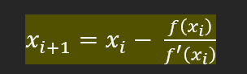

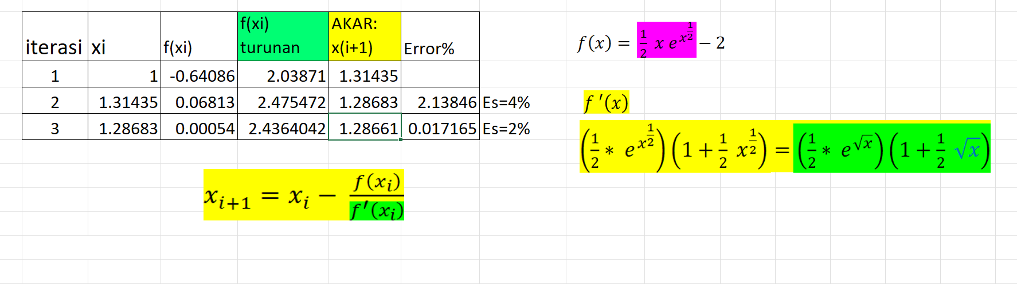

Metode Secant

Caranya sama kayak Raphson, tapi f’ nya = 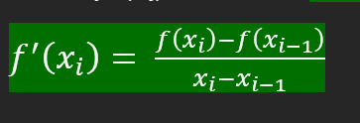

Newton:

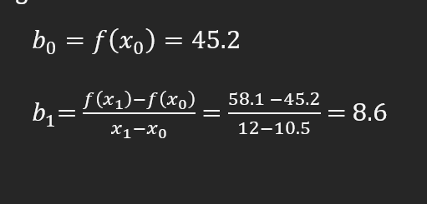

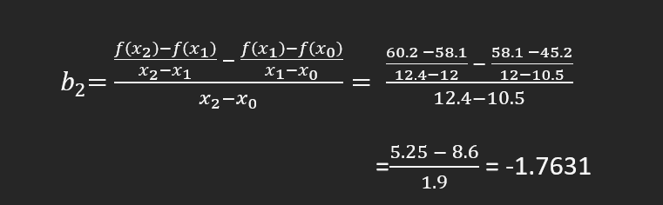

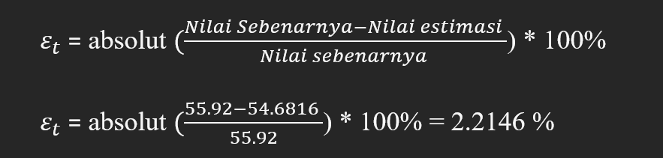

Metode Lagrange

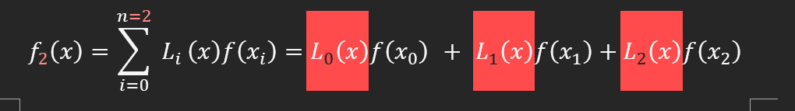

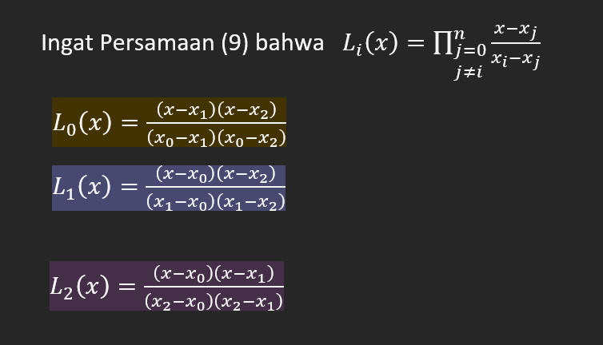

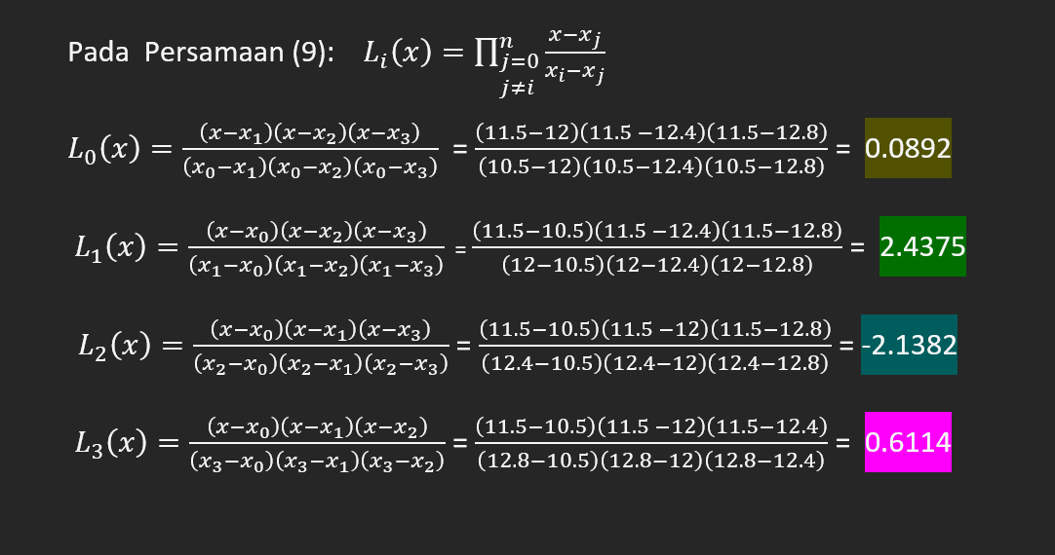

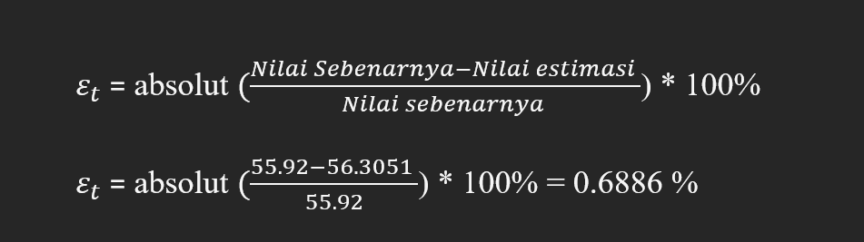

$$f\left(x\right)= \frac{1}{2}e^{x}-x^{3}$$